|  |  |
| --- | --- |
| **Preschool Services Department**  **Administration** | **Phalos Haire**  Director |

**FOR IMMEDIATE RELEASE (VOLUNTEERS NEEDED!)**

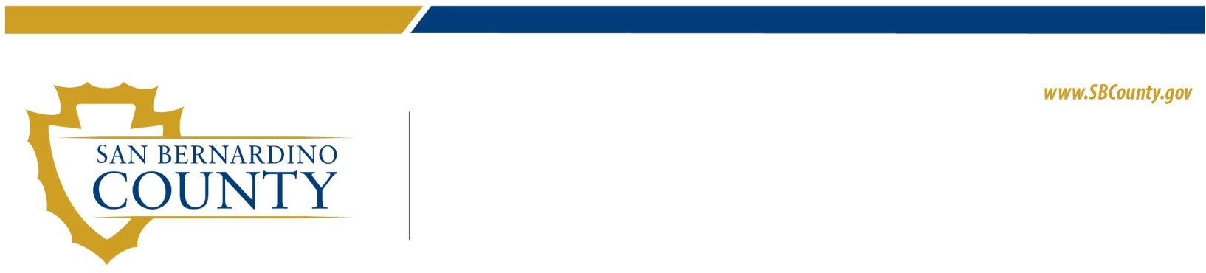

662 S. Tippecanoe Avenue, San Bernardino, CA 92415-0630 | Phone: 909.383.2078 Fax: 909.383.2080

San Bernardino County Preschool Services Department (PSD) is accepting applications from individuals interested in serving as Community Representatives on the Head Start Policy Council for the 2020-21 program year. Volunteer service in this role is limited to five one-year terms.

The Policy Council is a part of the formal structure of shared decision-making in the Federal Head Start/Early Head Start Child Development Program serving San Bernardino County. Meetings are held during the day, on the 3rd Monday of each month (or on the 3rd Tuesday if the 3rd Monday is a holiday), noting that conference call meetings may be scheduled as needed. According to the Federal Head Start Act, membership of the Policy Council must consist of parents of currently enrolled children, and community representatives drawn from former Head Start parents, the private community, civic and professional organizations, and others who are familiar with resources and services to low- income preschool age children and families.

The application can be found at <http://hs.sbcounty.gov/psd>, <https://www.facebook.com/SBCPSD/>, and <https://twitter.com/sbcpsd>.

Please submit completed applications no later than 5:00 p.m. on Friday, September 25, 2020 to:

SAN BERNARDINO COUNTY PRESCHOOL SERVICES DEPARTMENT 662 SOUTH TIPPECANOE AVE.

SAN BERNARDINO, CA 92415-0630

ATTN: Johnnetta Gibson, Program Specialist II

Completed applications and requests for further information may be emailed to [Johnnetta.Gibson@psd.sbcounty.gov](mailto:Johnnetta.Gibson@psd.sbcounty.gov)

